### Use case 1: User Registration

|  |  |
| --- | --- |
| Use Case ID | **UC1** |
| Use Case Name | Registration |
| Actor(s) | Blood Donor, Blood Seeker, Hospitals, Blood Banks |
| Purpose | For user registration |
| Pre-Conditions | User selected the registration form to fill |
| Post Conditions | Information is valid. Saved in database  Invalid Information. Error message displayed |
| Success Scenario | All provided information is valid. |
| User Action | **System Response** |
| **Users fill the required fields** | The system will save the data in the database. |

### Use case 2: Search Donors

|  |  |
| --- | --- |
| Use Case ID | **UC2** |
| Use Case Name | Search Donors |
| Actor(s) | Blood Seeker, Hospitals, Blood Banks |
| Purpose | For search Donors |
| Pre-Conditions | A user has selected donor's page. |
| Post Conditions | If internet connection is available. Donor found successfully  If internet connection is not available. The backup screen will be displayed |
| Success Scenario | Donors found it successfully. |
| User Action | **System Response** |
| **The user has chosen Donors Page** | The system will show all the donors to the user. |

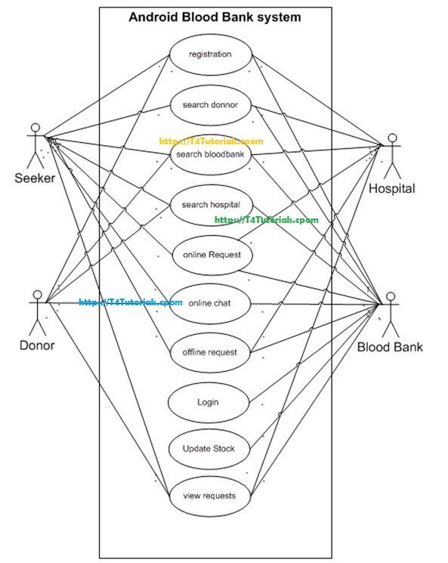**Figure:** use case diagram of blood bank management system

### Use Case 3: Search Blood banks

|  |  |
| --- | --- |
| Use Case ID | **UC2** |
| Use Case Name | Search Blood banks |
| Actor(s) | Blood Donor, Blood Seeker, Hospitals |
| Purpose | For search Blood banks |
| Pre-Conditions | The user has selected Blood bank page. |
| Post Conditions | If internet connection is available. Blood bank found successfully  If internet connection is not available. The backup screen will be displayed |
| Success Scenario | Blood bank found successfully. |
| User Action | **System Response** |
| **The user has chosen Blood bank Page** | The system will show all the Blood bank to the user. |

### Use Case 4: Search Hospitals

|  |  |
| --- | --- |
| Use Case ID | **UC2** |
| Use Case Name | Search Hospitals |
| Actor(s) | Blood Donor, Blood Seeker, Blood Banks |
| Purpose | For search Hospitals |
| Pre Conditions | A user has selected Hospital page. |
| Post Conditions | If internet connection is available. Hospital found successfully  If internet connection is not available. The backup screen will be displayed |
| Success Scenario | The hospital found it successfully. |
| User Action | **System Response** |
| **The user has chosen Hospital Page** | The system will show all the Hospital to the user. |

### Use case 5: Make an online request

|  |  |
| --- | --- |
| Use Case ID | **UC5** |
| Use Case Name | Manage Members |
| Actor(s) | Hospital, Blood bank, Blood Seeker |
| Purpose | Make Request for required blood |
| Pre-Conditions | The user selects the request page |
| Post Conditions | If Success data saved and displayed  If Failed error message will display and the backup screen will be displayed for the offline request |
| Success Scenario | All new data is valid and saved successfully |
| User Action | **Select request page and fill the form** |
| **Users fill the required fields** | The system will save the data in the database. |

### Use case 6: Online Chat

|  |  |
| --- | --- |
| Use Case ID | **UC5** |
| Use Case Name | Online Chat |
| Actor(s) | Blood Donors, Blood Seeker |
| Purpose | Online chat in case of zero balance to ask for the required blood |
| Pre-Conditions | The user selects the chat page |
| Post Conditions | If Internet Connection is available, messages will be sent and receive  If an error in Internet Connection, Conversion cannot be happening |
| Success Scenario | Successful conversation |
| User Action | **Select chat page and start chat** |
| **The user fills the chat field and submit** | The system will save the messages in the database. |

### Use case 7: Make offline blood request

|  |  |
| --- | --- |
| Use Case ID | **UC5** |
| Use Case Name | Make offline blood request |
| Actor(s) | Hospital, Blood bank, Blood Seeker |
| Purpose | Make offline Blood Request in case of no internet connection |
| Pre-Conditions | No internet connection |
| Post Conditions | If no internet connection backup screen will be displayed with the option of offline blood request |
| Success Scenario | All new data is valid and saved successfully in SQLite |
| User Action | **Select offline request option, fill the form, and refresh the application in case of internet connection** |
| **Users fill the required fields** | The system will save the data in the database. |

### Use Case 8: Login

|  |  |
| --- | --- |
| Use Case ID | **UC2** |
| Use Case Name | Login |
| Actor(s) | Blood Banks |
| Purpose | For accessing the blood bank operations |
| Pre-Conditions | User selected the blood bank module as a blood bank instead of a user. |
| Post Conditions | If internet connection is available. Login successfully  If internet connection is not available login failed |
| Success Scenario | View Blood bank Operations. |
| User Action | **System Response** |
| **The user has chosen Blood bank Page** | The system will show all the operations to the user. |

### Use Case 9: Update Stock

|  |  |
| --- | --- |
| Use Case ID | **UC2** |
| Use Case Name | Update Stock |
| Actor(s) | Blood Banks |
| Purpose | For updating the blood bank stock |
| Pre-Conditions | User selected the blood bank module as a blood bank instead of a user. |
| Post Conditions | If internet connection is available. Stock updated successfully  If internet connection is not available, then updating failed |
| Success Scenario | Updated bloodstock successfully. |
| User Action | **System Response** |
| **The user has chosen Blood bank Page** | The system will update the stock successfully |

### Use Case 10: View Requests

|  |  |
| --- | --- |
| Use Case ID | **UC2** |
| Use Case Name | View Requests |
| Actor(s) | Blood Donor, Blood Seeker, Hospitals, Blood Banks |
| Purpose | For View the Blood Requests |
| Pre-Conditions | The user has selected the Requests page. |
| Post Conditions | If internet connection is available. Requests found successfully  If internet connection is not available. The backup screen will be displayed |
| Success Scenario | View Requests successfully. |
| User Action | **System Response** |
| **The user has chosen Hospital Page** | The system will show all the Requests to the user. |